**WEB TECHNOLOGY**

**ASSIGNMENT-I**

TASK-1

Steps of creating a GIT repository named as your enrollment number. Create 2 folder in your repository named as Assignment_1 and Assignment_2.

**STEP-1:**

Go to :- <https://github.com>.

**STEP-2:**

Sign up (create a new account)

Log in (if your account already exist) with your email address.

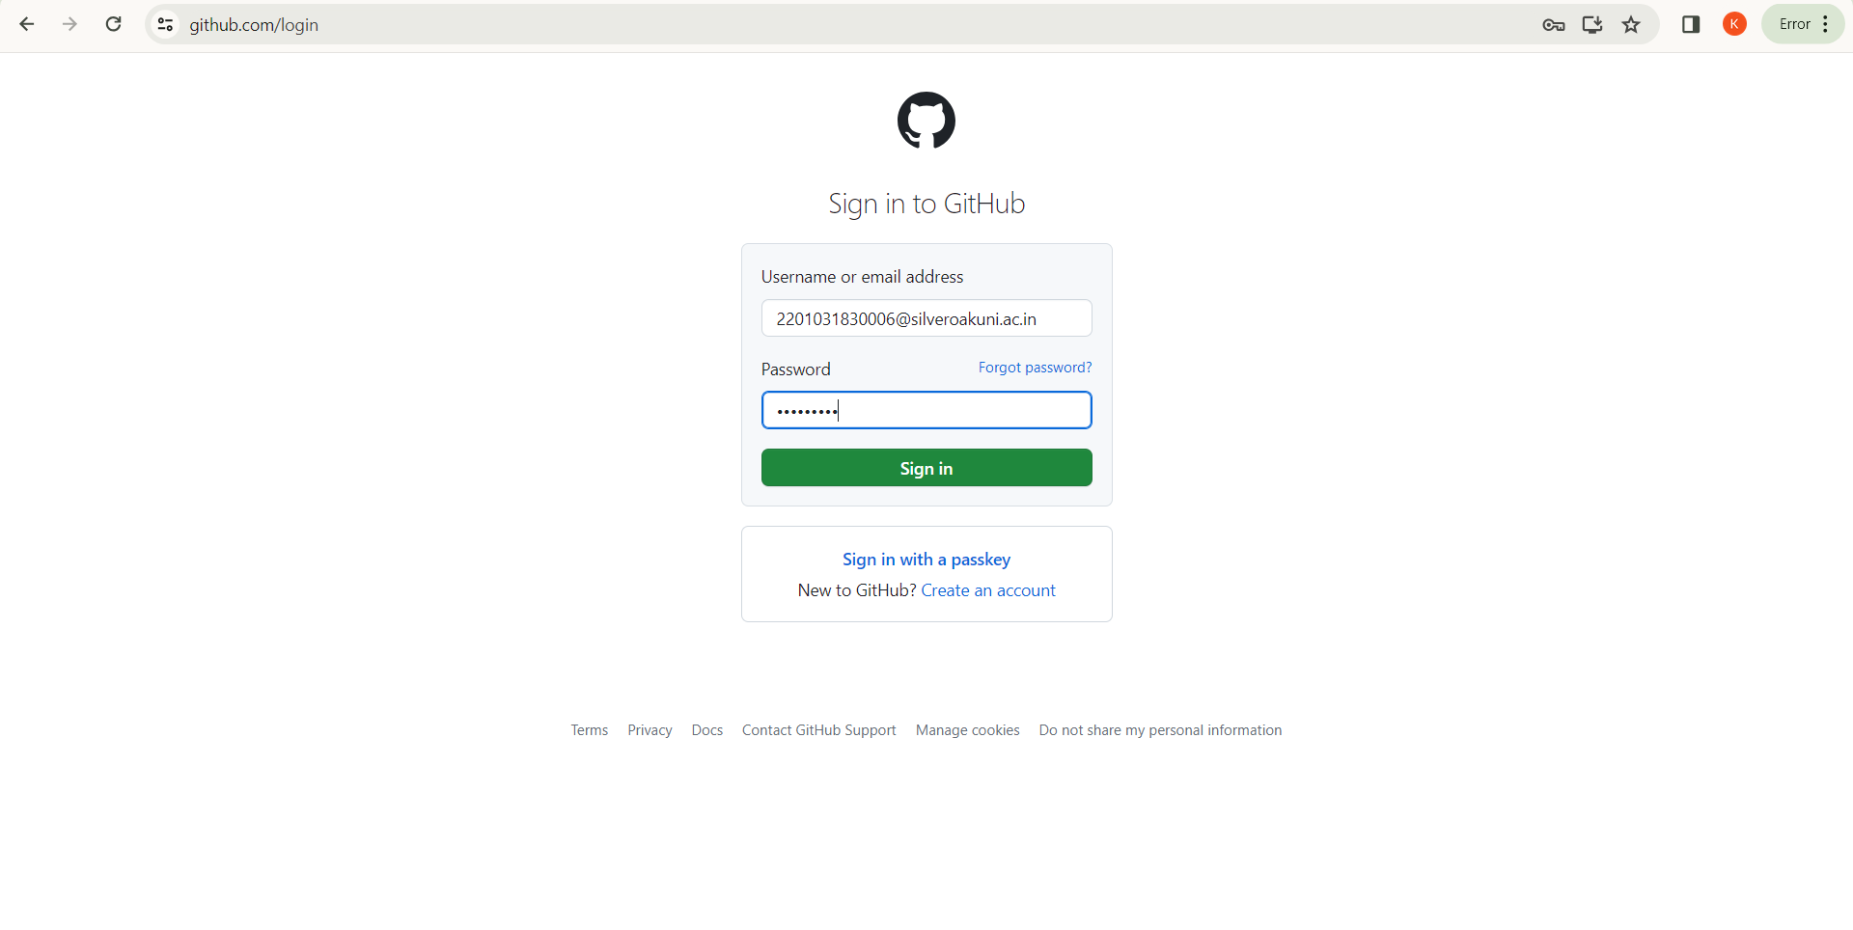

**STEP-3:**

A Homepage will appear as shown below & Click the top right corner:-

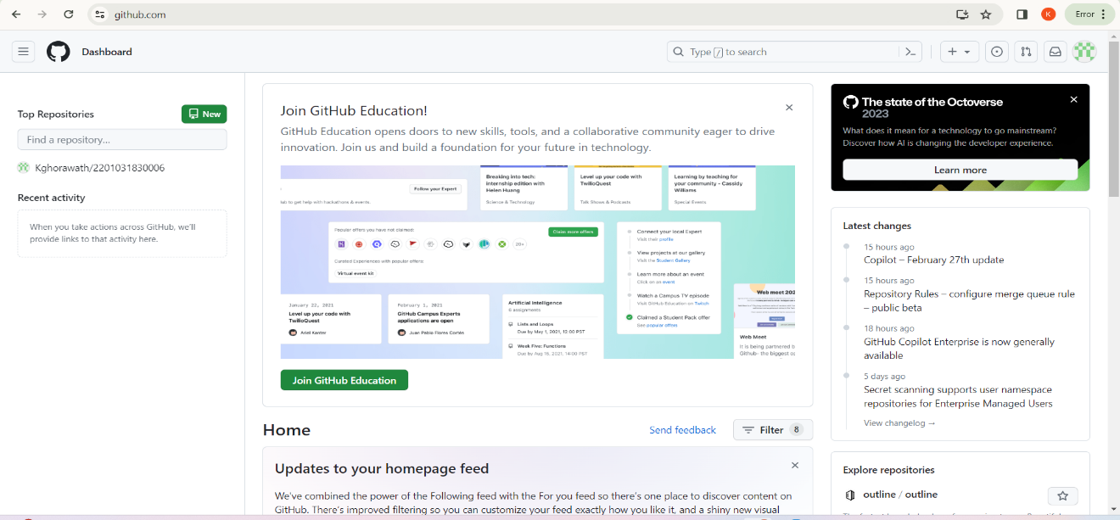s

**Step-4:**

Go to “**Your profile”**.

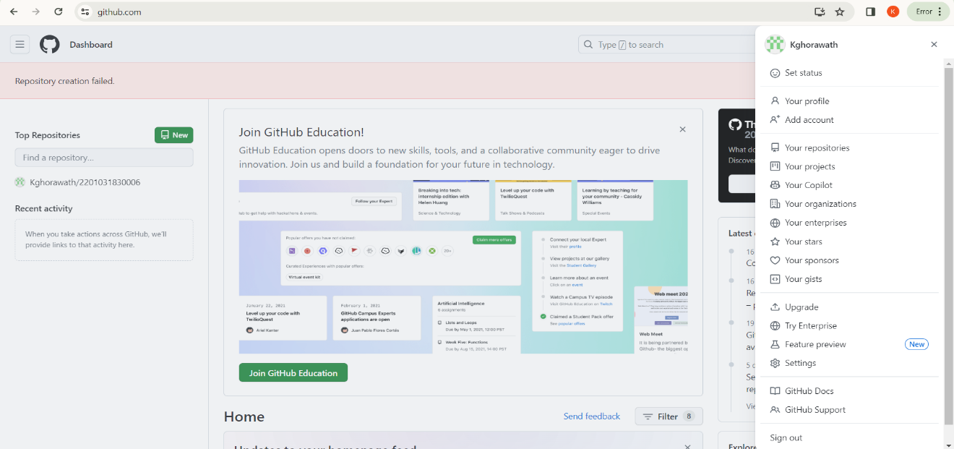

**Step-5:**

select “New” to make your repository.

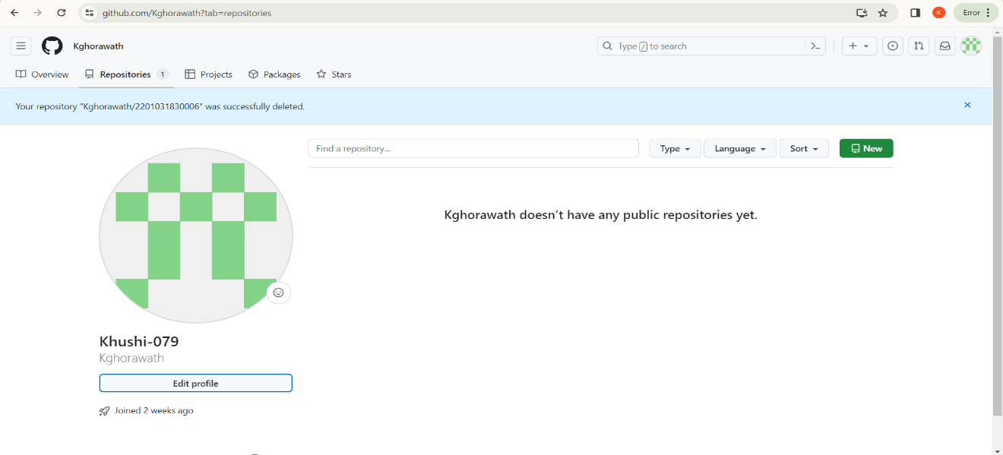

**Step-6:**

Enter your repository name (here I entered my enrollment no.-2201031830006 ). Write a description about your repository (which is an optional step). Select “Public”

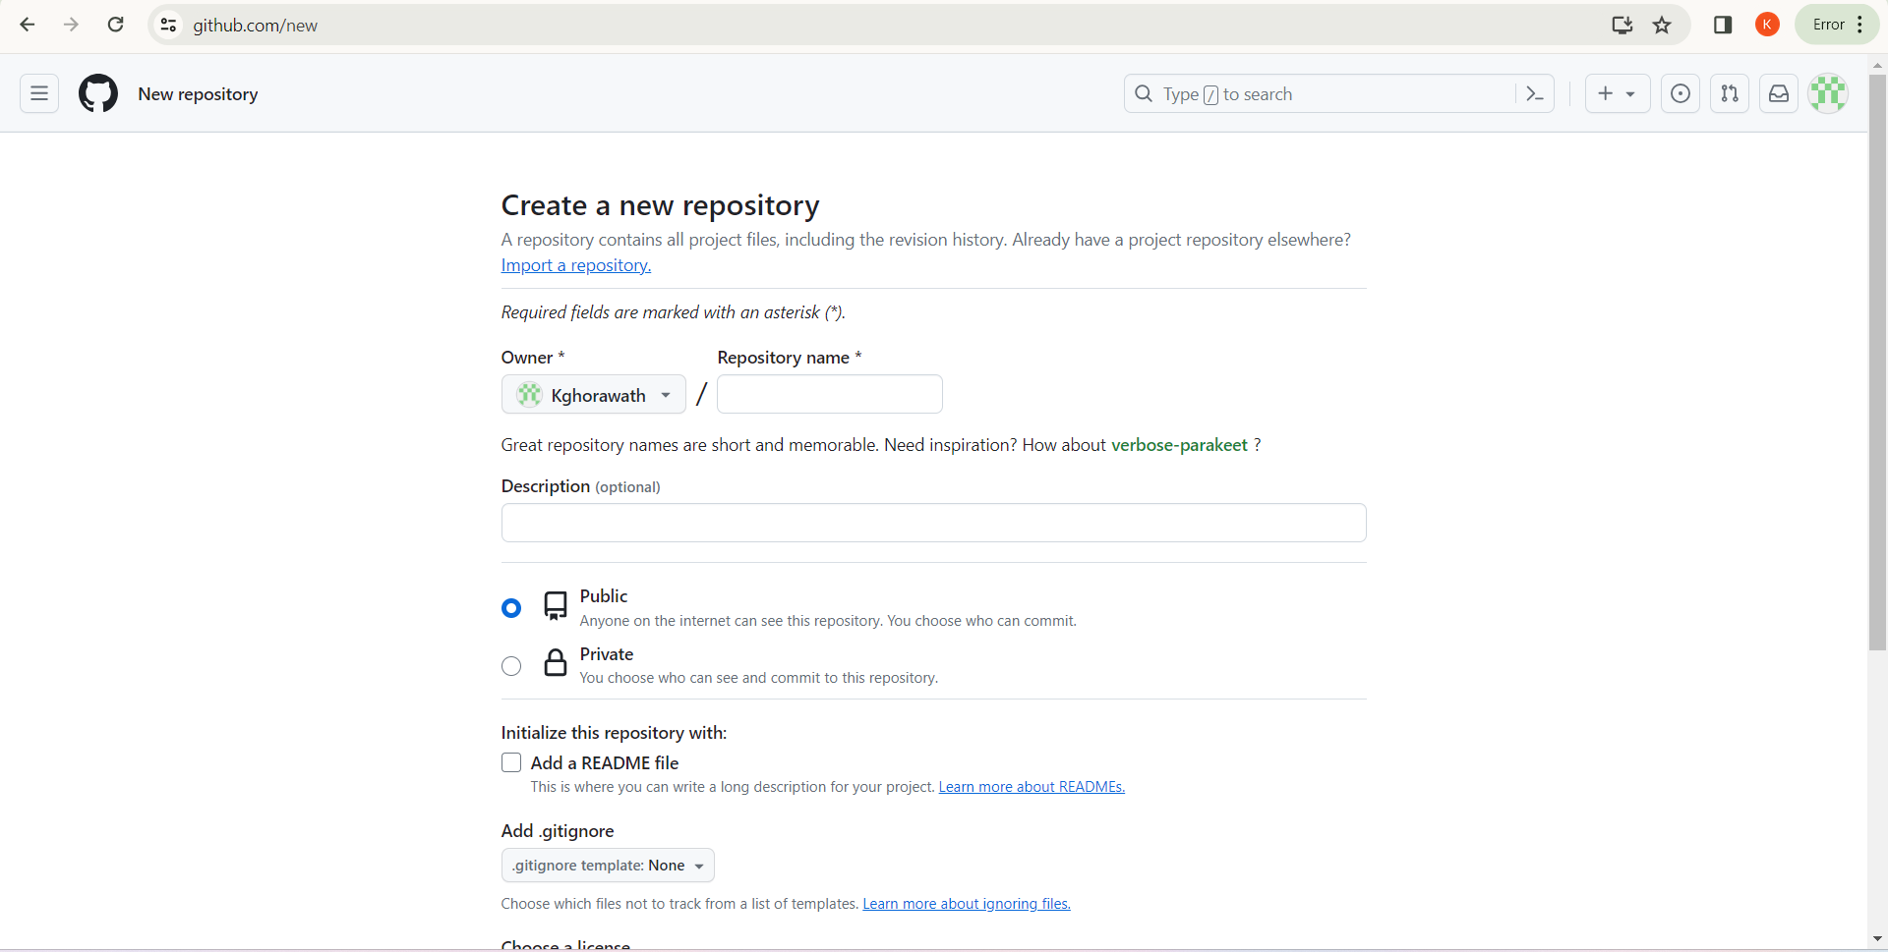

**Step-7:**

Scroll and select the checkbox “read me file” and click “Create repository”

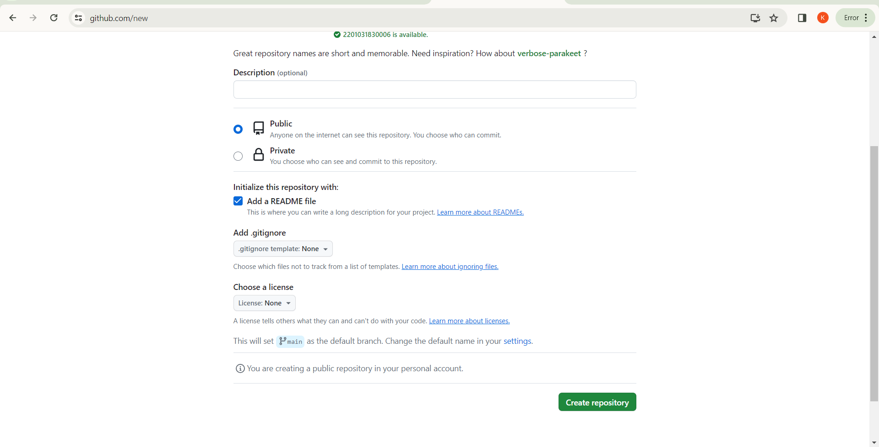

**Step-8:**

Finally you have successfully created your repository (2201031830006).

Now let’s create the folders named Assignment_1 and Assignment_2 in our created repository. For creating the folder, click “add file” then a drop down menu will appear, there click “create new file”.

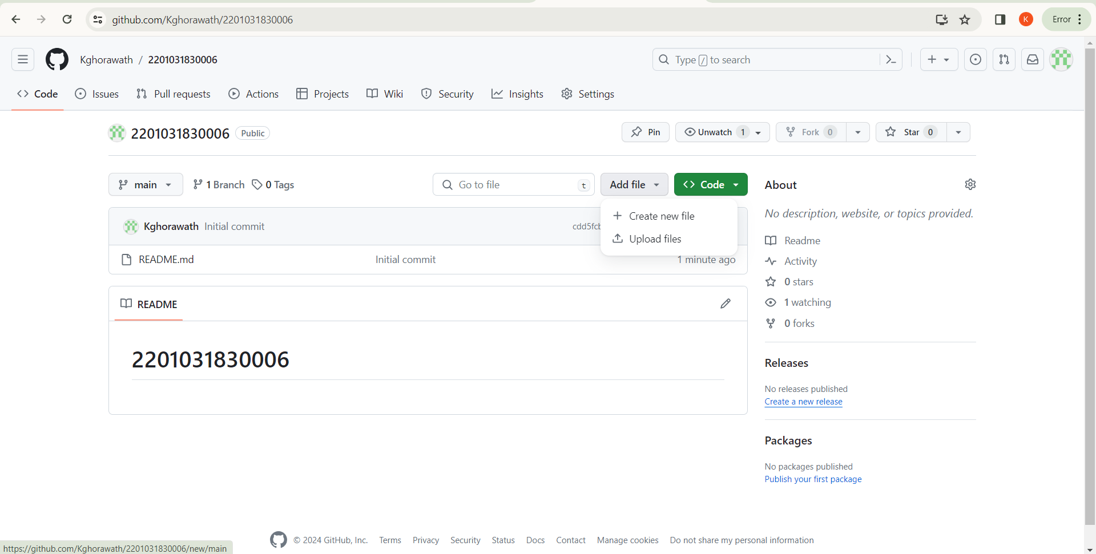

**Step-9:**

Enter your first folder name (Assignment_1), press “/” , enter your document file name and click “commit changes”.

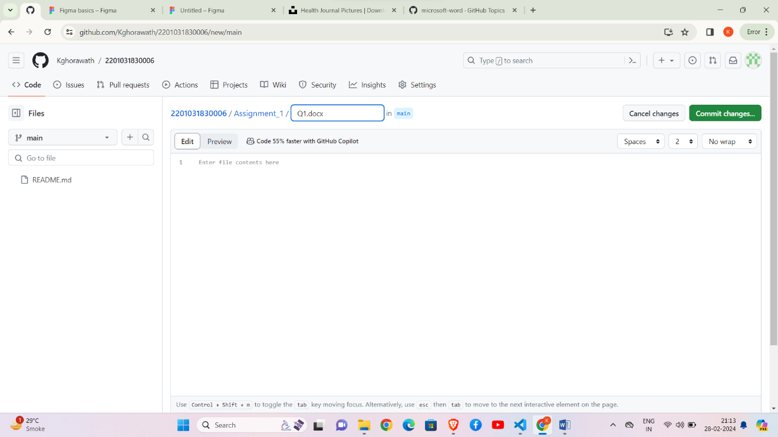

When you click “commit changes”, a commit message appears, also a text box named “extended description” appears where you can describe your changes in detail (which is again optional). Click “commit changes”.

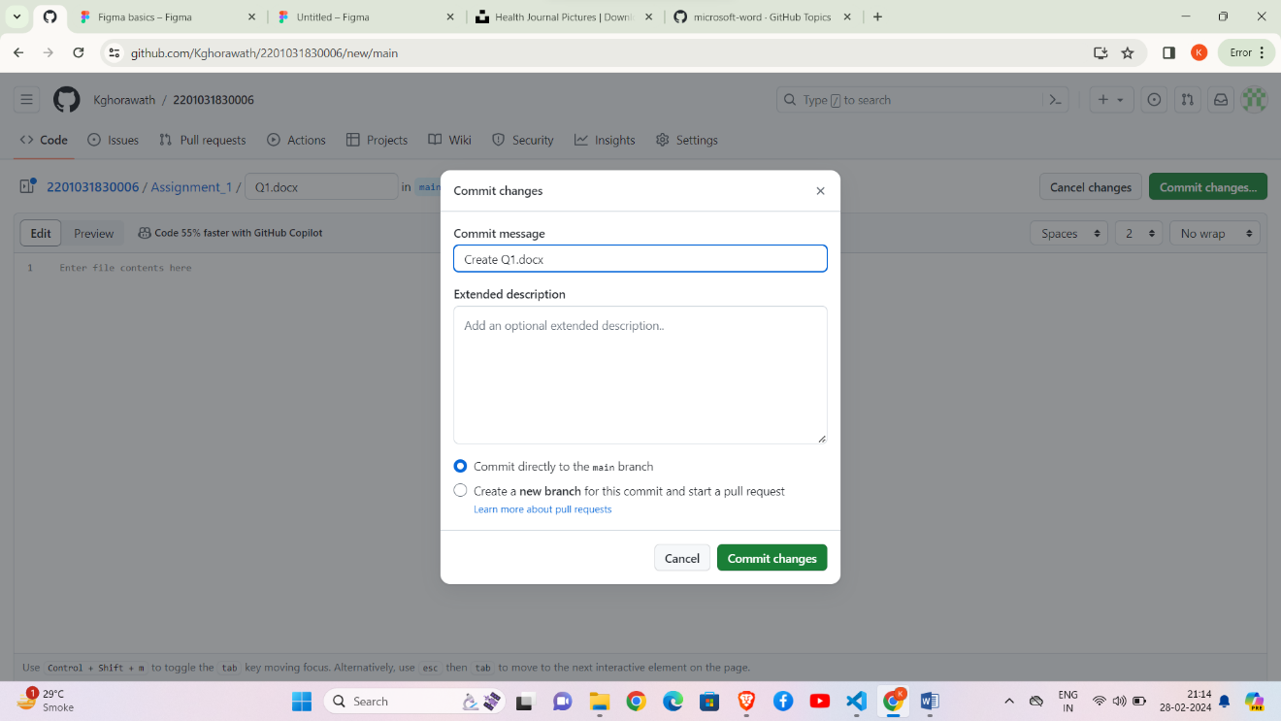

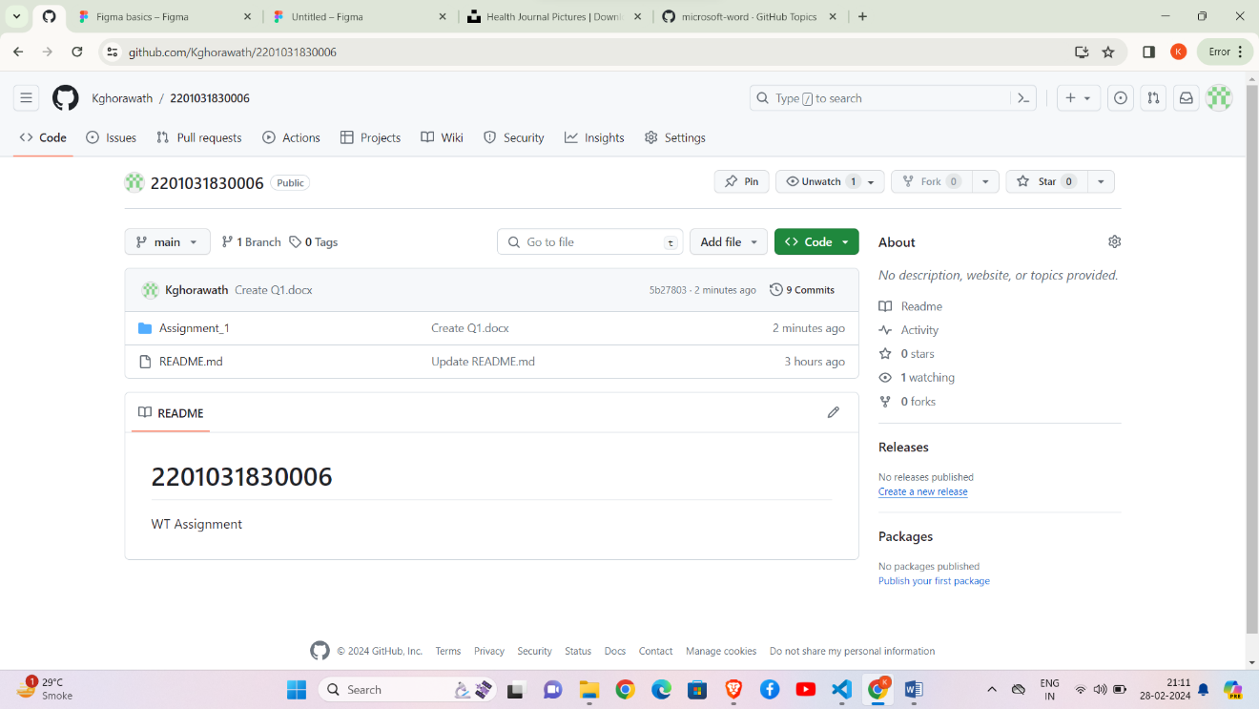

And so, your first folder named assignment_1 has been created in your repository. Follow the same steps and create the second folder named assignment_2 in the same repository (2201031830006).

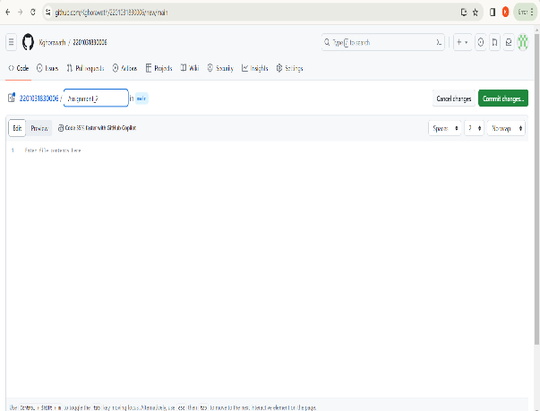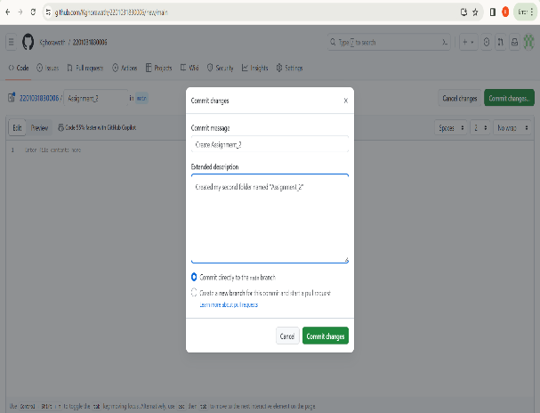

Now, both the folders (Assignment_1, Assignment_2) have been successfully created in your repository (2201031830006).

Finally your repository should look like the image shown below:-

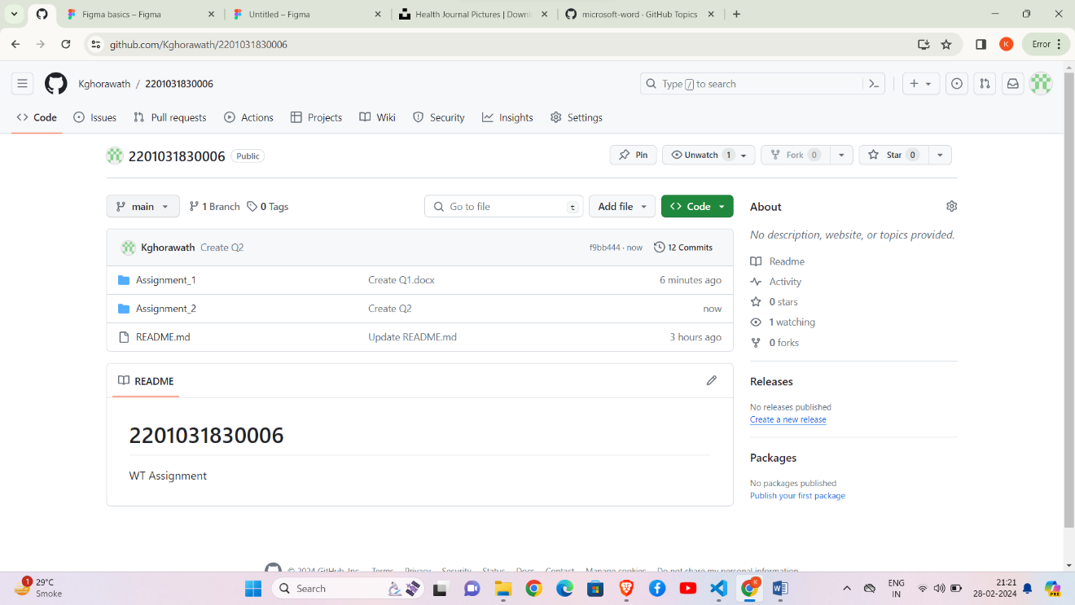

s

Here

2201031830006 is the repository name.

Assignment_1 and Assignment_2 are the two folder in the repository.